HUMAN HEALTH
OUR FOOD
A BALANCED DIET
- What is food? Something good to eat or drink.
- Why people eat food?
Hunger
Habit
Health
Happiness
Hospitality
- Importance of food to the human body
- - growth of the body
- - health of the body
- - provides energy to the body etc
(i) A balanced diet is a diet that contains all food values needed by the body.
Classes of food
These include; the 3G’s
- Glow foods
- Go foods
- Grow foods
- Glow foods[ mineral salts and vitamins]
- It is a class of food that gives health and protection to the body.
- Go foods[ carbohydrates]
- It is a class of food that gives energy to the body
- Grow foods[ proteins]
- It is a class of food that gives or makes the body to grow.
Foods values that make up a balanced diet

- Carbohydrates
- proteins
- vitamins
- mineral salts
- fats and oils
- roughages
- water

CARBOHYDRATES
- These are food values that provide energy to the body
- They are also called energy giving foods
Sources of carbohydrates

- Milk
- Bread
- Jam
- Sweet potatoes
- Cassava
- Maize
- Iris potatoes
- Yams

Lack of enough food or carbohydrates in the body causes marasmus or starvation
Signs of marasmus
- The eyes are very bright
- The face looks like that of an old man
- One becomes very thin
- A swollen pot belly stomach
Symptoms
- the child is underweight
PROTEINS
- These are food values that provide or build the body
- They are also called body building foods.
Uses of proteins in the body
- They are responsible for body growth
- They repair worn-out body cells or parts
- They help to make anti-bodies and enzymes
Sources of proteins

- Lean meat
- Groundnuts
- Cheese
- Eggs
- Fish
- Beans
- Milk Soya beans
- Soya beans

Lack of enough foods containing proteins in a diet causes kwashiorkor
Signs of Kwashiorkor
- A swollen face
- Little brown hair which falls of the head easily
- A swollen stomach full of air
- Swollen hands and legs
- When you press the skin, it takes long to come back in its position

VITAMINS
- These are food values that give health and protection to the body
Vitamins | Sources | Deficiency and symptom
A | Liver, egg yolk, carrots butter cold liver oil, green leafy vegetables | - Poor eye sight  - Reduced night vision.  - Night blindness
B₁ | Palm wine, beans, lean meat, egg yolk, milk, kidney bread, unpolished cereals, groundnuts | - Retorted growth  - Lack of appetite  - paralysis
B₂ | As for B1 plus yeast extracts | - Pellagra
C | Fresh fruits and vegetables, prepared concentrated frits | - Bleeding of gums  - Anaemia  - Scurvy
D  It is formed in the skin with the help of sunlight | Liver, milk, egg yolk, fish, margarine | - Weak bones  - Poor teeth

Note
A nutritional deficiency is a disease caused by failure to have enough of the food values in the body.

MINERAL SALTS
- These are food values that give health and protection to the body
Examples of mineral salts
Mineral salt | Sources | Function
Calcium | Milk, fish, whole grain cereal, cheese, beans bread, hard water, finger millet | - Strengthens bones and teeth  - Prevents rickets
phosphorous | Dairy foods, meat, fish, milk, eggs, cheese, cereals and green leafy vegetables | - Helps in absorption of carbohydrates
Iron | Meat, liver, kidney, egg yolk, green leafy vegetables, cocoa | - Helps in formation of haemoglobin  - Lack of iron causes anaemia
Iodine | Sea water, sea food, sea weeds like algae and iodized salts | - It is essential to proper working of the thyroid glands  - Lack of iodine causes goitre

FATS AND OILS
- These provide the body with energy and heat
- In mammals, fats are stored under the skin
Sources of fats and oils

- milk
- butter
- egg yolk
- ghee
- groundnut
- palm oil
- simsim
- cheese

Functions of fats and oils
- Fats and oils provide warmth and energy
- They protect the heart and kidney
- They assist in making body cells
Note
- Too much fats and oils in a diet will lead to obesity and other health problems.
Effects of too much fats and oils to body

- lack of energy
- thinness
- feeling cold
- vitamin A and D deficiency

ROUGHAGES
This is the un digestible fibres from the cell walls of plants
Sources of roughages

- Green leafy vegetables
- Sweet potatoes
- Bread and flours
- Cassava
- Fresh fruits
- Peas
- Rice
- Nuts and seeds
- Dried fruits

Functions of roughages
- It allows easy movement of food through the intestines
- It adds bulk to food
- It aids digestion
- It helps to prevent constipation
- Reduces the risk of bowel cancer
- Encourages chewing of food
Lack of enough foods containing roughages in the diet leads to constipation
WATER
- Water helps in easy digestion and absorption of food
- It helps in reducing body temperature by sweating
-It forms the basis of the blood as plasma

How food gets contaminated

- By serving food using dirty hands
- By serving food using dirty containers
- By leaving it uncovered
- Preparing food from dirty places
- Keeping food in dirty places or containers
Effects of food contamination
-It leads to diarrhoeal diseases like typhoid.
-It results into stomach disorders.
-It leads to poverty in families.

Prevention of food contamination

- By covering food properly
- Serving food in clean containers
- Serving food from clean places
- Preparing food with clean hands

Food preparation
-Boiling food -Frying food
-Steaming
-Roasting food
Food preservation
-Smoking -Refrigerating
-Sun drying
-Salting
Advantages of preserving food
-It promotes food hygiene.
-It enables people to keep food for long time.
Food hygiene: Is the keeping of food clean or free from germs.
Food security: Refers to ensuring that there is enough food to be eaten and for the future.
Importance of food security
-It helps people to protect them against famine outbreak.
-It helps people to get rid of malnutrition in their families.
TOPIC 2
THE HUMAN BODY ORGANS
Major organs of the human body include;

Eyes
Brain
Ears
Stomach
Bladder
Heart
Lungs
Liver
Kidney

THE EYES
The eyes or eyeball is placed in a strong socket in a skull for protection.
Uses of the eyes
- It is a sense organ for seeing
- It helps in estimating distance
Diagram of the front view of the eye
Eyebrows
Eyelashes
Upper eyelid

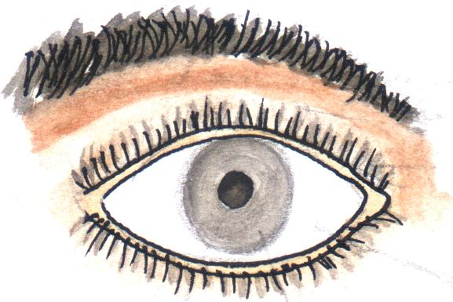
Lower eyelid
Iris

sclera
E – Eyelashes
L – Eyelids
I – Iris
P – Pupil
Functions of the parts
- Eyelids help to cover the eye
- Eye lashes and eyelids help to prevent foreign bodies from entering the eye.
- The iris is a coloured dark brown, black blue broad ring found in the middle of the eye
- The iris helps to control the amount of light that reaches the retina
- The iris helps to control the size of the pupil
Diseases that affect the eye

- Trachoma
- conjunctivitis
- impetigo

Ways of caring for the eyes
- Washing eyes with clean water and soap regularly
- do not touch the eyes with dirty hands
- Do not share materials or shake hands with persons with eye diseases or infection
- Visiting the oculist in case of any eye problems

THE EAR
- The ear is the sense organ for hearing
- The ear helps in body balancing
Structure of the outer ear
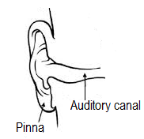

Pinna
- It helps to collect, trap and direct sound to the ear drum
Auditory canal
- It is the passage for sound waves to the ear drum
- The auditory anal contains special sebaceous glands which secret wax
- Wax and hair help to trap dust and germs from entering into the ear
Diseases of the ear
-earache
-ear discharge
Disorder of the ear
-Deafness -Ringing of the ears (tinnitus)
Care for the ears
-Do not use sharp objects to clean ears
-Wash ears daily with soap and clean water
-Do not stay in a very noisy place
-Always visit ear nose throat doctor (ENT) for check up
THE BRAIN
The brain is found in head
- The brain is protected by a skull or cranium
Uses of brain
-for memory
-for thinking
-for controlling body movement
-for storing information
-for interpreting information
Diagram showing the brain

Disease of the brain

- Epilepsy
- Poliomyelitis
- Stroke
- Meningitis
- Almery disease
- Cerebral malaria

THE LIVER
- The liver is a reddish – brown organ which lies just below the diaphragm and partly covering the stomach.
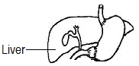

Functions of the liver
-It regulates blood sugar
-It produces bile
-It helps to produce heat
-It helps to store vitamin A and D
-It regulates the amount of proteins
-It removes harmful substances like alcohol

Diseases of the liver
- Cirrhosis of the liver:
- Hepatitis
- Liver abscess (it is a disorder)

THE STOMACH
- The stomach is a large muscular sac.
- The stomach walls help to produce gastric juice and hydrochloric acid.
Use of stomach
-Stores food for some time

Structure of the stomach
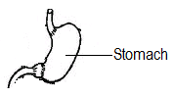

Disorders of the stomach
- Peptic ulcers
- Constipation
- Indigestion
- Gastritis
THE HEART
- It helps to pump blood to all body parts
- The heart is protected by the rib cage
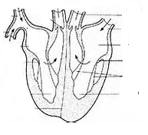

Diseases of the heart
- Heart attack/coronary disease
Ways of maintaining proper working of the heart
- Eat a balanced diet
- Always have regular meals
- Eat meals containing low animal fat
- Doing regular exercises

The kidney and urinary bladder

- The kidneys are two bean shaped organs situated at either side of the lower abdomen
Urinary bladder
-Stores urine for some time
Diagram of the kidney and urinary bladder
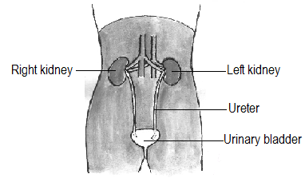

Functions of the kidney
- It helps to filter blood
- It controls the amount of water and salts in the blood and body tissues
Note:
- The ureter helps to carry urine from the kidneys to the urinary bladder
Disease of the kidneys
- Kidney failure
- Kidney cancer
- Kidney stones
Care for the kidneys
- Eat a balanced diet
- Do not hold back urine
- Drink enough water
- Avoid swimming in dirty water
- Do not eat or take too much salt
THE LUNGS
- Lungs are organs for gaseous exchange
Gaseous exchange takes place in air sacs
Lungs are protected by the rib cage
Diagram showing lungs
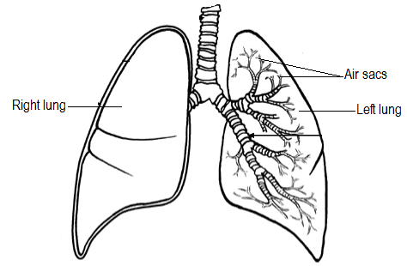

- Oxygen is breathed in and carbon dioxide is breathed out.
Diseases of the lungs

- Pneumonia

- Bronchitis
- Tuberculosis
- Diphtheria
- Whooping cough
- Asthma

Ways of maintaining proper working of lungs
- Do not smoke
- Avoid being in places with a lot of smoke
- Avoid being in dusty places
- Carry out regular physical exercise
- Eat a balanced diet

TOPIC 3
HUMAN BODY
THE TEETH
- The teeth are hard bone like- structures found in the mouth
Sets of teeth
- Milk set
- Permanent set
Milk set
- It is a set of teeth which appears first in babies after the age of 6 months
- They last up to 6 years
- They start falling out one by one and later replaced by the permanent set of teeth
- The milk set consists of 20 teeth
Arrangement of teeth in the milk set
 | incisors | canines | premolars | Total
Lower jaw  Upper jaw  Total | 4  4  8 | 2  2  4 | 4  4  8 | 10  10  20

The permanent set of teeth
- This is the second and final set of the teeth in man
- The permanent set of teeth consists of 32 teeth
- It has the following types of teeth
- incisors
- canines
- premolars
- molars
Regions of a tooth
CROWN
- This is the part above the gum mainly the enamel.
NECK
- This is the region on the same level with the gum where the crown joins the root
THE ROOT
- This is the part which is sunk or fixed in the socket of the jaw.
TYPES OF TEETH
They include;

- Incisors
- Canines
- Premolars
- Molars

- Incisors.
- These are sharp chisel – shaped teeth at front of the mouth
- They are flat on top
- Incisors are used for cutting food.
- They are four in each jaw of man.
- Incisors are well developed in;
- rats
- rabbits
- squirrels
Structure of an incisor tooth
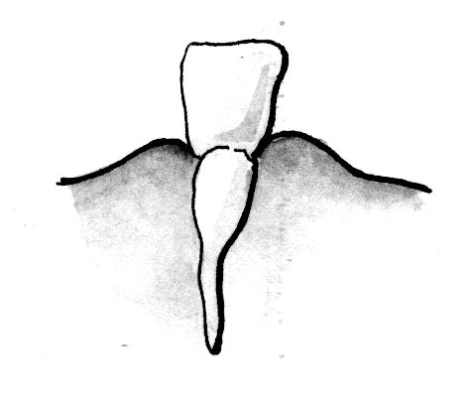

- Canines
- These are sharp cone - shaped teeth
- They are pointed and stronger in the jaw.
- They are two in each jaw on either side of the incisors
- They are used for tearing food.
- They are most developed in;

- Dogs
- Cat
- Leopards
- Lions
- Tigers

Structures of a canine tooth
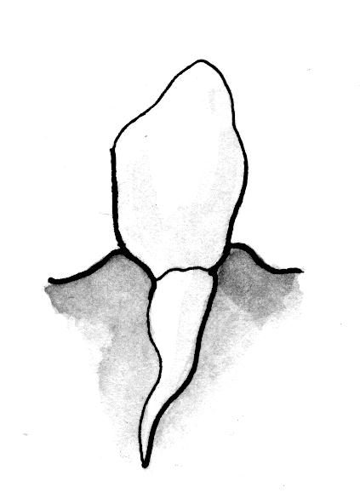

- Pre - Molars
- These are blunt rigged teeth in front of the molars.
- They have flat tops with cusps
- They have two roots
- Premolars are used for chewing, crushing and grinding food
- They are four of them placed in pairs after each canine tooth in each jaw.
Structure of a premolar tooth
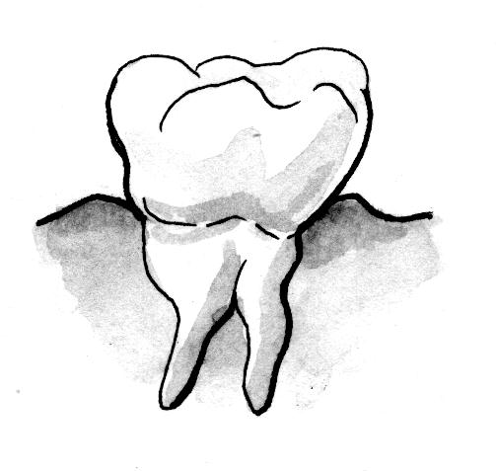

- Molars
- These are blunt broad ridged teeth.
- They have a larger surface area
- They have flat tops with cusps like the premolars
- They are six in each jaw
- The molars in the lower jaw have two roots but in the upper jaw have three roots
Diagram showing structures of molar teeth
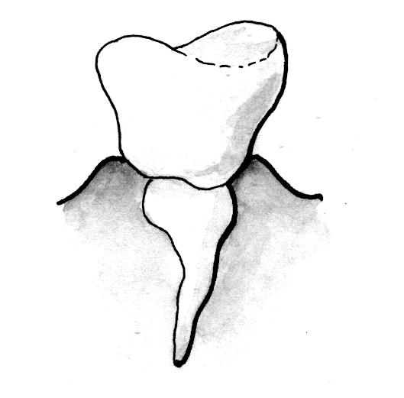

Internal parts of the teeth

- Canine tooth
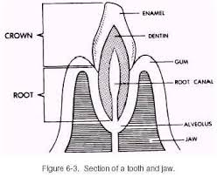

E – Enamel
D – Dentine
P – Pulp cavity
G – Gum
C – Cement
J – Jaw bone
B – Blood capillaries
N – Nerve fibres

- Molar tooth

E – Enamel
D - Dentine
S – Sensory nerve ending
G – Gum
C – Cement
P – Pulp cavity
B – Blood capillaries
J – Jawbone

Enamel
  - This is the hardest part of the tooth
  - It is the hardest tissue in the body of an animal.
  - The enamel prevents wear and tear of the teeth
  - The enamel is made from calcium and phosphorus
Dentine
- It forms the biggest part of the teeth
- It contains living cells and channels through which the dentine receives
Pulp cavity
- It contains blood vessels teeth forming cells and sensory nerves
- The sensory nerves are sensitive to heart, cold and pain
- The blood vessels bring digested food to the teeth.
Cement
- This helps to fix the tooth in its socket by the tough fibres in it and the jaw.
Gum
- This gives extra support to the tooth into the jaw bone.
Jaw bone
- This holds the tooth in position
Dentition
This is the arrangement of teeth in the mouth.
Dental formula is the formula showing the number and kinds of teeth in the mouth.
Dental formula of an adult person

 | Incisors | Canines | premolars | Molars | Total
Lower jaw  Upper jaw | 4  4 | 2  2 | 4  4 | 6  6 | 16  16
Total | 8 | 4 | 8 | 12 | 32

Disorders of the teeth
- Improper growth
- Broken teeth
- Teeth cracks
- Dental cavities
Teeth diseases
These include
- Dental caries
- Periodontal disease
- Plaque
- pyorrhoea
Dental caries
- It is the scientific name for tooth decay.
- It is caused when bacteria act on the sugars and starch which remain on the teeth after eating
- Action of bacteria on sugars and starch lead to the production of lactic acid.
- The lactic acid slowly wears and tears the enamel and dentine leading to the formation of cavities
- The pulp cavity is destroyed by bacteria if the cavities are not treated

Plaque
- This is a coating on the teeth caused by saliva containing mucus bacteria and other organic substances.
- Plague destroys mostly the crown and the gum
- Plague causes gum swelling called gingivitis

Note:
Calculus is a black hard substance that forms on the teeth.
Periodental disease
- This is an inflation of the gums and tooth sockets
- This disease is caused when plaque is neglected which results in gingivitis
Care of the teeth
- Brush teeth sing fluoride tooth paste
- Avoid eating sweets and sweetened foods like sweets, biscuits
- Brush the teeth daily
- Do not drink hot or very cold foods
- Rinse your mouth with water and salt every after a meal
- Eat plenty of fresh fruits and vegetables
- Do not open bottles using the teeth.

Topic 4
Human health
Sanitation
- sanitation is the general cleanliness of the places where we stay and live
Or: Sanitation are the steps taken to promote pubic cleanliness involving community efforts to disease prevention.
Concerns of sanitation
- Having a latrine or toilet for proper disposal of faeces and urine
- Having rubbish pits and dust bins for proper disposal of house hold refuse like peelings
- Slashing around our homes
- Draining a way all stagnant water
- Sweeping away all the rubbish in our compound
- Having a plate stand or rack in our homes
Importance of good sanitation.
-t reduces the spread of germs and vectors in the environment.
-it reduces bad smell in the environment
--It prevents contamination of food and water sources.
It promotes good health.

Germs and diseases
Germs are microscopic organisms which cause diseases.
Germs are commonly found in rubbish pits, pit latrines, air, soil, water, dirty food. Rotting fruits etc
Ways of protecting ourselves against germs
- Proper disposal of faeces and urine.
- Proper disposal of rubbish.
- Water for drinking.

GERMS AND DISEASE
- Germs are tiny living organisms that cause diseases
- Germs are found in;
- water
- soil
- decaying matter
- bodies of animals (man)
- air
- on plants
- blood
- faeces
- urine
Ways how germs are spread
- Through air
- Though insets bites
- Through close body contact with an infected person
- Through cuts and wounds on the body
- Through animals bites

Note:
- A disease an illness or disorder caused by an infection or unnatural growth
- The types of germs include;
- Bacteria
- Fungi
- Protozoa
- virus
- The 4 F’s
- faeces
- flies
- food
- finger
- Germs cause rotting by feeding on the dead organism.

